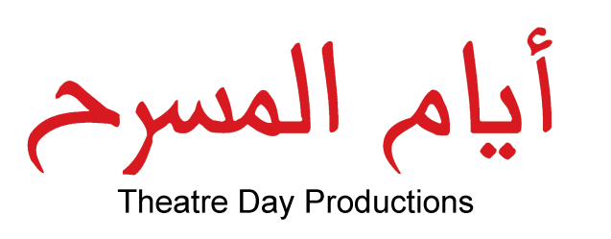
Drama Improves Key Competences in Education
Program
December 19,2010
Ramallah

9:00-9:30 Registration of participants
Coffee
9:30-10:10 Opening session- Mr. Amer Khalil, General Director, & Mr. Jan Willems, Artistic Director, Theatre Day Productions.
10:10-10:20 Her Excellency Lamis Alami, Minister of Education & Higher Education.
10:20-10:40 Professor Nabil El-Haggar, Vice-President of Lille University, chargé of Culture, Communication and Scientific Heritage “The Importance of Culture and Drama in Society and Education in the Arab world”.
10:40-11:10 Dr. Adam Jagiello Rusilowski, Director for Development, Education Department, University of Gdansk “Drama as a Social and Educational Glue”.
11:10-11:30 Mr. Jan Willems, Artistic Director, Theatre Day Productions, “Drama Improves Key Competences in Education”
11:30-11:45 Coffee Break
11:45-12:05 Dr. Hala Al-Yamani, Assistant Professor, Faculty of Education, Bethlehem University, “Impact of the Drama on the Practice of Primary School Teachers”.
12:05-12:25 Mrs. Ilham Abd ElKader Muheissen, General Director of Student Activities Department- Ministry of Education & Higher Education, “Impact of Extra-Curriculum Activities on the Educational Process mainly Educational Theatre and Drama”.
12:30-13:30 Lunch
13:30-14:30 Discussion of working groups
14:30-15:00 Recommendations

